

RECIPE BOOK
March 2026

Allergens

14 known allergens can be found in the food.
These allergens are:
- Gluten
- Peanuts
- Tree nuts
- Celery
- Mustard
- Eggs
- Milk
- Sesame
- Fish
- Crustaceans
- Molluscs
- Soya
- Sulphites
- Lupin

Vegetable Pitta Pizzas
Ingredients
- Pitta bread  - Chopped tomatoes  - Tomato Puree  - Onions | - Peppers  - Cheddar / dairy free cheese | 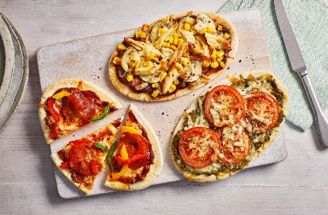
Method
- Preheat the oven to 180°C.
- Place the Pitta bread on a baking tray.
- Spread Tomato sauce over each pitta using a spoon.
- Sprinkle grated Mozzarella cheese on top.
- Add the chopped vegetables such as Bell pepper, Tomato, and Sweetcorn.
- Bake in the oven for 8–10 minutes until the cheese melts.
- Let it cool slightly, cut into slices, and enjoy.

See Allergens - Gluten, Milk

Tomato Soup
Ingredients
- Chopped tomatoes  - Vegetable stock  - Onions  - Garlic | - Cream | 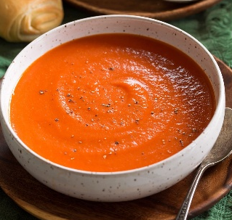
Method
- Heat Olive oil in a saucepan.
- Add the chopped Onion and cook for about 3–4 minutes until soft.
- Add the Garlic and cook for 1 minute.
- Add the chopped Tomatoes and cook for 5 minutes.
- Pour in the Vegetable stock and simmer for 10 minutes.
- Blend the soup carefully until smooth.
- Serve warm. Add a little Cream..

See Allergens - Milk

Chinese Chicken Curry with Rice
Ingredients
- Chicken  - Onion  - Carrots  - Peas  - Curry Powder | - Chicken stock  - Rice  - Corn flour (to thicken) | 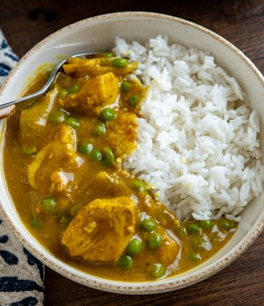
Method
- Heat Vegetable oil in a frying pan.
- Add the Chicken breast pieces and cook until lightly brown.
- Add the chopped Onion, and Carrot. Cook for 3–4 minutes.
- Stir in the Curry powder.
- Pour in the Chicken stock. Simmer for about 10 minutes.
- Mix Cornflour with a little water and add to the pan to thicken the sauce.
- Serve with Rice.

See Allergens – N/A

Mince with Mashed Potatoes & Veg
Ingredients
- Beef mince  - Beef stock  - Potatoes  - Carrots | - Peas  - Onions  - Soft spread | 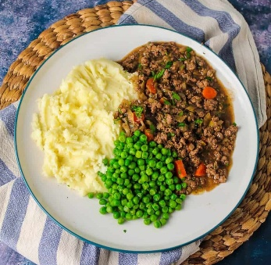
Method
- Boil the chopped Potatoes in a saucepan for about 15 minutes until soft.
- Heat a frying pan and cook the Minced beef with the chopped Onion for 5–7 minutes.
- Add the diced Carrots and Beef stock, then cook for another 5 minutes.
- Boil peas in a pot and drain once soft.
- Drain the Potatoes and mash them with Soft spread.
- Serve the mince with the mashed potatoes on the side.

See Allergens – N/A

Rice Pudding & Banana
Ingredients
- Pudding rice  - Soft spread  - Cow’s / oat milk  - Cinnamon | - Banana | 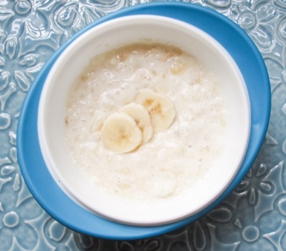
Method
- Add the Pudding rice and Milk to a large pot.
- Cook on low heat, stirring regularly so the rice does not stick.
- Simmer for 1 hour 30 minutes until the rice is soft and the mixture is creamy.
- Stir in the Butter. Mix well until the butter melts and blends in.
- Sprinkle Cinnamon, then serve warm.
- Cut banana and serve at side.

See Allergens – Milk

Broccoli Soup
Ingredients
- Olive oil  - Broccoli florets  - Potatoes  - Onion  - Vegetable stock | - Soft spread | 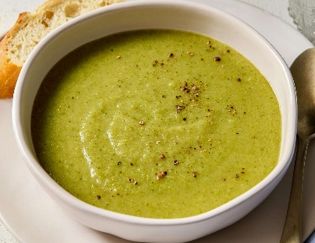
Method
- Heat the Butter or Olive oil in a saucepan.
- Add the Onion and cook for 3–4 minutes until soft.
- Add the Broccoli florets and diced Potato. Cook for 2–3 minutes.
- Pour in the Vegetable stock and simmer for 10–12 minutes until the vegetables are tender.
- Blend carefully until smooth.
- Serve warm.

See Allergens – N/A

Tomato & Vegetable Pasta
Ingredients
- Pasta  - Onion  - Carrots  - Mixed herbs  - Chopped tomatoes |  | 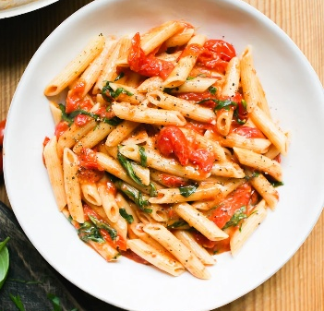
Method
- Cook the Pasta in boiling water according to packet instructions. Drain and set aside.
- Heat Olive oil in a pan, add Onion, and cook for 3–4 minutes until soft.
- Add the diced Carrot and cook for 5 minutes until slightly tender.
- Add the Chopped tomatoes, stir, and simmer for 5–7 minutes until the sauce thickens slightly. Season lightly with Mixed herbs.
- Mix the cooked Pasta into the sauce. Serve warm.

See Allergens – Gluten

See Allergens – Fish

Fish Pie with Carrots & Peas
Ingredients
- White fish fillets  - Potatoes  - Soft spread  - Milk | - Carrots  - Peas | 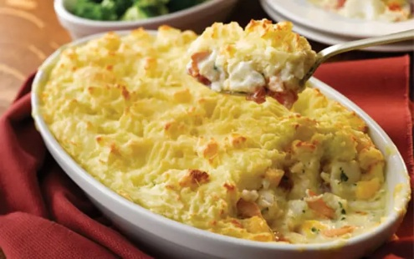
Method
- Prepare the mash: Boil the Potatoes until soft (about 15 minutes). Mash with Butter and Milk. Set aside.
- Cook the fish: Steam or gently poach the White fish fillets for 5–7 minutes until cooked through. Flake into large chunks.
- Prepare vegetables: cook the diced Carrot and Peas until tender.
- Assemble the pie: Place the fish and vegetables in an ovenproof dish. Spread the mashed potato on top evenly.
- Bake: Heat in a preheated oven at 180°C (350°F) for 15–20 minutes until the top is lightly golden. Serve warm.
Fajita Chicken & Rice
Ingredients
- Chicken breast  - Peppers  - Onions  - Fajita seasoning | - Rice | 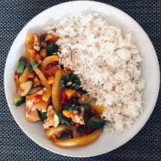
Method
- Cook the rice: Bring Water to boil. Add Rice, cover, and simmer for 10–12 minutes until tender.
- Heat Olive oil in a frying pan.
- Add the Chicken breast and cook until no longer pink (5–7 minutes).
- Add Onion and Bell peppers, sprinkle with Fajita seasoning, and cook for 3–4 minutes until vegetables are soft.
- Serve the chicken and vegetables over the cooked Rice.

See Allergens – Soya

Sausages with Mashed Potatoes & Beans
Ingredients
- Pork sausages  - Potatoes  - Soft spread  - Beans |  | 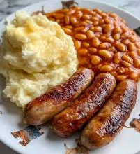
Method
- Look the potatoes: Boil the peeled and chopped Potatoes in water for about 15 minutes until soft. Drain.
- Mash the potatoes: Add Butter, mash until smooth.
- Cook the sausages: Oven cook the Sausages until golden brown and cooked through (15–20 minutes), turning occasionally.
- Cook the beans as per manufacturers instructions.
- Serve the sausages with mashed potatoes and beans on the side.

See Allergens – Gluten

Chicken and Rice Soup
Ingredients
- Chicken breast  - Rice  - Carrots  - Celery  - Onion | - Chicken stock | 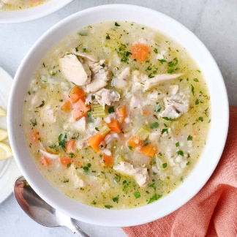
Method
- Heat Olive oil in a saucepan.
- Add Onion, Carrot, and Celery stick. Cook for 3–4 minutes until soft.
- Add the Chicken breast pieces and cook for 5 minutes until lightly browned.
- Pour in the Chicken stock and bring to a gentle boil.
- Stir in the Rice, reduce the heat, and simmer for 15–20 minutes until the rice and chicken are fully cooked.

See Allergens – Celery

Cheese and Ham Toasties with Salad
Ingredients
- Bread  - Cooked sliced ham  - Cheddar / dairy free cheese  - Lettuce  - Tomatoes | - Cucumber | 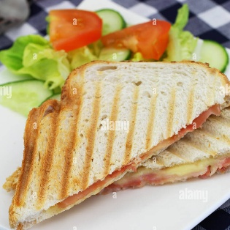
Method
- Place the Ham and Cheese between the slices of bread.
- Toast in a sandwich toaster or grill for 3–5 minutes until the cheese melts and the bread is golden.
- Wash and chop lettuce, tomatoes and cucumber
- Serve with side salad.

See Allergens – Milk, Gluten

Vegetable Soup
Ingredients
- Olive oil  - Onions  - Carrots  - Potatoes  - Vegetable stock |  | 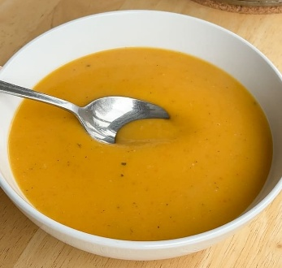
Method
- Heat Olive oil in a saucepan.
- Add the Onion, Carrot and Potato. Cook for 5–6 minutes until soft.
- Pour in the Vegetable stock, bring to a gentle boil, then simmer for 10–15 minutes until all vegetables are tender.
- Blend the soup for a smooth, creamy texture suitable for younger children.
- Serve warm.

See Allergens – N/A

Fish Cakes, Potato Wedges & Peas
Ingredients
- Breaded cod fish cakes (see packaging)  - Potato wedges (see packaging)  - Peas |  | 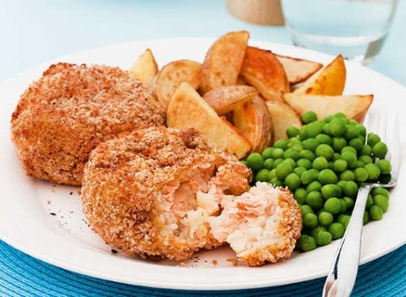
Method

- Pre-heat oven.
- Place potato wedges on a baking tray lined with greaseproof baking paper.
- Cook for 20-25 minutes.
- Place fishcakes on a baking tray lined with greaseproof baking paper.
- Cook for 15-20 minutes, until crisp and golden, turning half way through.
- Boil peas until soft, drain and serve along with fish cakes and potato wedges.

See Allergens – Fish, gluten

Spaghetti Bolognaise
Ingredients
- Spaghetti  - Beef mince  - Onions  - Carrots  - Chopped tomatoes | - Tomato puree  - Beef stock | 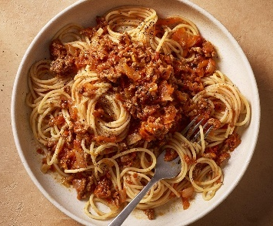
Method

- Cook the Spaghetti according to packet instructions. Drain and set aside.
- Heat Olive oil in a pan, add Onion and Carrot. Cook for 5 minutes until soft.
- Add the Minced beef and cook until browned.
- Stir in the Chopped tomatoes and Tomato puree and Beef stock. Simmer for 15–20 minutes.

See Allergens – Gluten

Chicken and Broccoli Pasta
Ingredients
- Pasta  - Chicken breast  - Broccoli florets  - Milk or cream  - Cheddar / dairy free cheese |  | 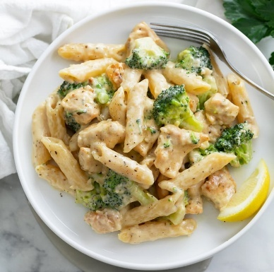
Method

- Cook the Pasta according to packet instructions. Add Broccoli florets in the last 3–4 minutes of cooking. Drain and set aside.
- Heat Olive oil or Butter in a frying pan. Add the Chicken breasts and cook until fully cooked (5–7 minutes).
- Add the drained pasta and broccoli to the pan with chicken. Stir in Milk or cream and cheese/dairy free cheese, and cook for 2–3 minutes until warmed through.

See Allergens – Gluten, Dairy

Macaroni Cheese with Corn on the Cob
Ingredients
- Macaroni pasta  - Butter (dairy free)  - Plain flour  - Cheddar / dairy free cheese | - Milk  - Corn on the cob | 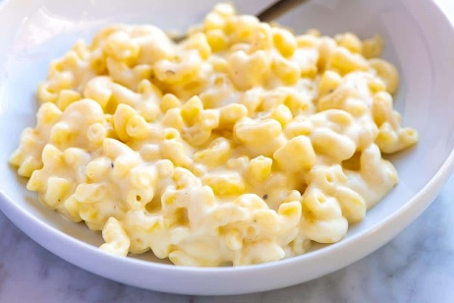
Method

- Cook the Macaroni pasta according to packet instructions. Drain and set aside.
- In a saucepan, melt Butter over low heat. Stir in Flour and cook for 1–2 minutes to make a roux.
- Gradually whisk in the Milk, stirring constantly until smooth and thickened.
- Add the grated Cheddar cheese and stir until melted.
- Mix in the cooked pasta until fully coated.
- Pour into an ovenproof dish, grate cheese on top and bake at 180°C (350°F) for 10–15 minutes until golden on top.

See Allergens – Gluten, Dairy

Steak Pie with Potatoes, Peas & Carrots
Ingredients
- Puff pastry  - Diced beef  - Onions  - Beef stock  - Potatoes | - Carrots  - Peas | 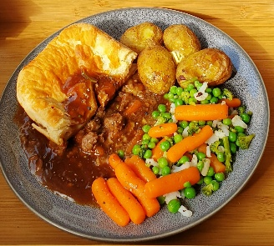
Method

- Heat oil in a pan, add beef and cook until browned.
- Add onion and carrot. Cook for 5 minutes until soft.
- Add beef stock/gravy
- Cover and cook on low heat for about 1–1.5 hours (until beef is tender).
- Cut and boil potatoes in pot until soft.
- Pour filling into an oven dish. Lay puff pastry on top and press edges down.
- Cook for 20–25 minutes until golden and puffed.
- Serve with peas and carrots.

See Allergens – Gluten, Soya, Celery

Chilli and Rice
Ingredients
- Minced beef  - Onion  - Carrot  - Chopped tomatoes  - Chilli con carne mix  - Kidney beans | - Rice | 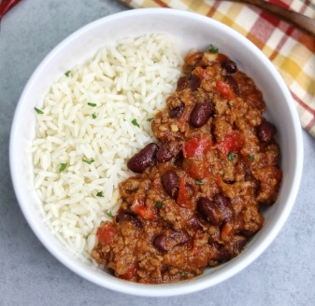
Method

- Boil rice according to packet instructions, then drain.
- Heat oil in a pan. Add mince and cook until browned.
- Stir in onion and carrot. Cook for 5 minutes until soft.
- Sprinkle in the chilli con carne mix. Add chopped tomatoes + water (follow packet amount) and stir well.
- Stir in kidney beans.
- Cook for 15–20 minutes until thick.

See Allergens – Gluten

Fruit Salad
Ingredients
- Apples  - Banana  - Orange  - Melon |  | 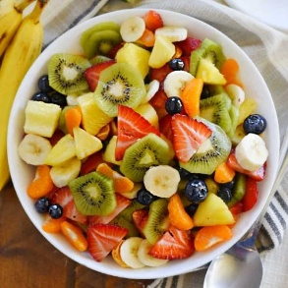
Method

- Wash all fruit.
- Chop into small thinly sliced pieces.
- Add everything into a bowl.
- Squeeze orange or lemon on top.
- Chill in fridge

See Allergens – N/A

Chicken and Sausage Jambalaya
Ingredients
- Chicken breast  - Sausages  - Onions  - Carrots  - Chopped tomatoes | - Chicken stock  - Paprika  - Rice | 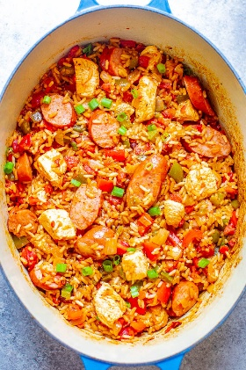
Method

- Heat oil in a large pan. Add chicken and sausage, cook until lightly browned.
- Add onion and carrot, cook for 5 minutes until soft
- Stir in uncooked rice and paprika.
- Pour in chopped tomatoes and chicken stock.
- Stir, cover, and cook on low for 20–25 minutes.
- Stir occasionally until rice is soft and liquid absorbed

See Allergens – Gluten, Eggs

Chicken Korma with Rice
Ingredients
- Chicken breast  - Onions  - Korma curry paste  - Coconut milk  - Mango chutney | - Rice | 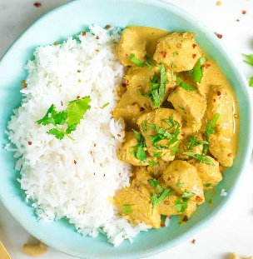
Method

- Boil rice according to packet instructions, drain, set aside.
- Heat oil in a pan. Add chicken and cook until lightly browned.
- Stir in onion and cook for 5 minutes until soft.
- Stir in korma paste and cook for 1 minute.
- Pour in coconut milk and add mango chutney.
- Cook on low for 15–20 minutes until chicken is cooked and sauce thickens.

See Allergens – N/A

Beef Stir Fry with Noodles
Ingredients
- Beef strips  - Stir fry mix  - Black bean sauce  - Egg noodles |  | 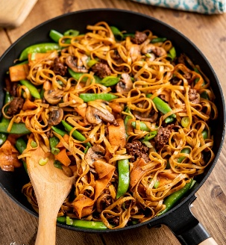
Method

- Stir fry noodles according to manufacturer’s instructions.
- Heat oil in a wok or large frying pan. Add beef strips and cook 7-10 minutes until browned. Remove and set aside.
- In the same pan, add stir fry mix and fry until tender
- Return beef to the pan. Add black bean sauce mix.
- Stir well and cook 2–3 minutes to coat beef and vegetables.
- Toss in cooked noodles and mix thoroughly.

See Allergens – Eggs, Gluten, Soya

Greek Yoghurt with Fruit
Ingredients
- Greek Yoghurt / Dairy free yoghurt  - Fruit |  | 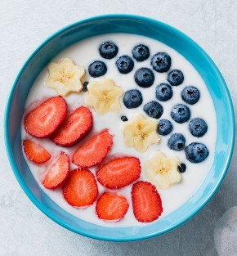
Method

- Cut fruit
- Serve alongside Greek yoghurt

See Allergens – Dairy (Greek yoghurt)

Fish Curry with Naan Bread
Ingredients
- White fish fillets  - Onions  - Mild curry powder  - Chopped tomatoes  - Coconut milk | - Peas  - Naan bread | 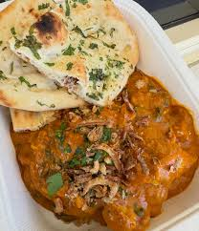
Method

- Pre-heat oven. Wrap fish fillets in foil and cook at 180°C for 21-23 minutes.
- Heat oil in a pan over medium heat. Add onion and cook 3–5 minutes until soft. Stir in curry powder or korma paste for 1 minute.
- Pour in chopped tomatoes and coconut milk. Stir well and simmer for 5 minutes.
- Gently add cooked, cut fish pieces. Cover and simmer for 8–10 minutes
- Heat naan in the oven or microwave according to packet instructions.

See Allergens – Fish, Gluten

Spaghetti Carbonara
Ingredients
- Spaghetti  - Eggs  - Parmesan cheese  - Diced pancetta  - Double cream |  | 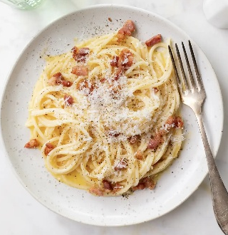
Method

- Boil spaghetti according to packet instructions.
- Fry chopped bacon/pancetta in a pan for 2–3 minutes until lightly crisp.
- In a bowl, beat eggs with Parmesan and cream.
- Turn heat down very low on the bacon pan.
- Add drained spaghetti to the pan.
- Pour egg & cheese mixture over spaghetti and stir quickly.

See Allergens – Eggs, Dairy, Gluten

Chicken in Gravy, Boiled Potatoes & Green Beans
Ingredients
- Chicken breast  - Potatoes  - Onions  - Chicken Gravy  - Chicken stock  - Green Beans |  | 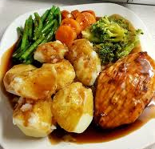
Method

- Boil chopped potatoes in large pot
- Boil green beans in a separate pan for 4–5 minutes until just tender.
- Cook chicken in pot until golden and cooked through. Add chicken stock and onion
- Add chicken gravy to chicken
- Serve alongside potatoes and green beans

See Allergens – Soya, Gluten

